**Komal Atif**

**53635**

**TASK NO: 01**

Write an assembly language program that find the square of a number entered by user. Print the result on screen

.model small

.stack 100h

.data

msg DB 'Enter a number$'

msg1 DB 'Square$'

.code

Main Proc

mov ax,@data

mov ds,ax

mov dl,msg

mov dx,offset msg

mov ah,9

int 21h

mov ah,1

int 21h

sub al,'0'

mul al

AAM

mov ch,ah

mov cl,al

mov dl,10

mov ah,2

int 21h

mov dl,13

mov ah,2

int 21h

mov dl,msg1

mov dx,offset msg1

mov ah,9

int 21h

mov dl,ch

add dx,48

mov ah,2

int 21h

mov dl,cl

add dx,48

mov ah,2

int 21h

mov ah,4ch

int 21h

main endp

end main

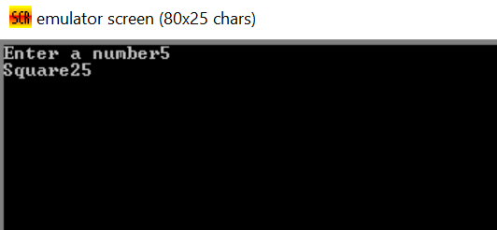

**TASK NO: 02**

Write an assembly language program that find the cube of a number entered by user. Print the result on screen.

.model small

.stack 100h

.data

msg DB 'Enter a number:$'

msg1 DB 'Cube=$'

.code

Main Proc

mov ax,@data

mov ds,ax

mov dl,msg

mov dx,offset msg

mov ah,9

int 21h

mov ah,1

int 21h

sub al,'0'

mov bl,al

mul bl

mul bl

AAM

mov ch,ah

mov cl,al

mov dl,10

mov ah,2

int 21h

mov dl,13

mov ah,2

int 21h

mov dl,msg1

mov dx,offset msg1

mov ah,9

int 21h

mov dl,ch

add dx,48

mov ah,2

int 21h

mov dl,cl

add dx,48

mov ah,2

int 21h

mov ah,4ch

int 21h

main endp

end main

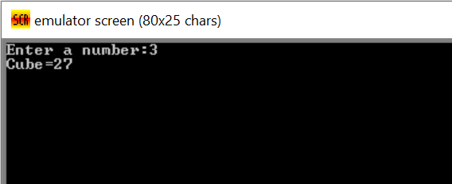

**TASK NO: 03**

Perform multiplication of two numbers entered by user. Print the result on screen

.model small

.stack 100h

.data

.code

Main Proc

mov ah,1

int 21h

mov bl,al

sub bl,48

mul bl

mov ah,1

int 21h

mov cl,al

sub cl,48

mov al,bl

mul cl

AAM

mov ch,ah

mov cl,al

mov dl,ch

add dl,48

mov ah,2

int 21h

mov dl,cl

add dl,48

mov ah,2

int 21h

mov ah,4ch

int 21h

main endp

end main

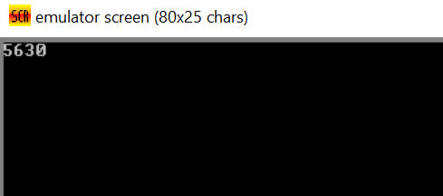

**TASK NO: 04**

Write an assembly language program that finds the area of a triangle

.model small

.stack 100h

.data

.code

Main Proc

mov ah,1

int 21h

mov bl,al

sub bl,48

mov ah,1

int 21h

mov cl,al

sub cl,48

mov al,bl

mov bl,2

mul cl

div bl

mov dl,al

add dl,48

AAM

mov ch,ah

mov cl,al

mov dl,ch

add dl,48

mov ah,2

int 21h

mov dl,cl

add dl,48

mov ah,2

int 21h

mov ah,4ch

int 21h

main endp

end main

